Wise Words - Hampton Court Palace
Gary Wise
This week, Wise Words hits the road for London. I write this bound for England where I'll be spending the eight days prior to Barcelona testing IBC, IBL, and my limits with regards to excess and my capacity for sleep deprivation. London is an important place in the Magic world right now and it all centers around the dwelling in which I'll be spending the majority of my time.
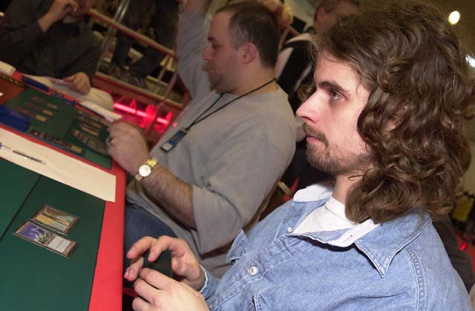
The Ben Ronaldson
When you ask Randy Buehler what the center of the Magic universe is right now, the answer is a surprising one. One might guess New Jersey, home of Jon Finkel himself, Renton, Washington, home of WotC headquarters or Boston, which seems to have a higher Pro-to-population ratio than any city on the planet, but instead of an entire city, Randy's answer is Hampton Court Palace, home of Ben and Ivan Ronaldson. Ben's Pro Tour record doesn't shine as brightly as some; he made his one Top 32 this year at Worlds, while Ivan has only made one PT but it isn't their play that that makes this dwelling so important.
Simply, the Palace is the gathering place for London's (and England's) finest players. There, they draft and construct, and while they're still learning about the former, they've mastered the latter. The last two Constructed Pro Tours were won by players using English creations and they don't appear to be ready to slow down soon.
These deckbuilding achievements are led by the holy triumvirate of Ben, Warren Marsh and John Ormerod. Ben and Warren put in as much if not more time testing than anyone while it's John, the creator of such decks as Trinity, Red Deck Wins 2000 and the Solution, who serves as a source of deck inspiration.
What's the secret of their success? If I knew all the answers I'd probably keep them to myself, but from working with them for PT Chicago, it's obvious that one element is hard work. Instead of returning testing results with scores of 9-6, 8-4 or 3-5, they return numbers like 56-43, 19-26 and 48-30. Included are notes on every game, noting losses due to everything from mana trouble to a poor card. Through this constant effort they are able to weed out the weaker cards in their decks. That, in part, is how you win Pro Tours.
Here then is a brief look at the major players in the English Magic community with regards to the Pro Tour. This is a collection of players you should not only respect, but from who you can learn by example. Play your decks, play them some more and keep strict, point blank data. That's how these guys have made themselves the center of the universe.

Warren Marsh - With apologies to Pat Chapin, Warren is the thinnest man on Pro Tour. Well known for the suits he wears in competition, Warren's drive to succeed is matched only by his love of women and his penchant for the finer things in life. A Masters competitor, he got there by virtue of his second place finish at PT-NY in May. There, of the seventeen million some-odd Rebel decks played, only Warren's was steered to the finals.
John Ormerod - If there's a Zen to Magic, it is embodied by John O. With a quiet clarity, John, who is Warren's antithesis when it comes to excess, approaches new environments with a brainstorming approach and quietly solves the puzzle the world seeks to solve during Constructed season. Considered one of the country's two best Limited players, John had his lone Top 8 at PT-Mainz back in the day, but more recently finished 9th at PT-Chicago '99.
Ben Ronaldson - It was Chicago '99 that really put the English on the map because the deck they played, Cocoa Pebbles, was universally considered the best in the tournament. Only a year and a half into the game at the time, it was Ben, co-creator of Trinity, who steered the team towards combo, which was thought to be dead by many. Possessing of a quick wit, fast emotions and a faster tongue, Ben's goals of the last two years were to win Regionals and Nationals respectively, both of which he accomplished. This year's goal: win Euros.
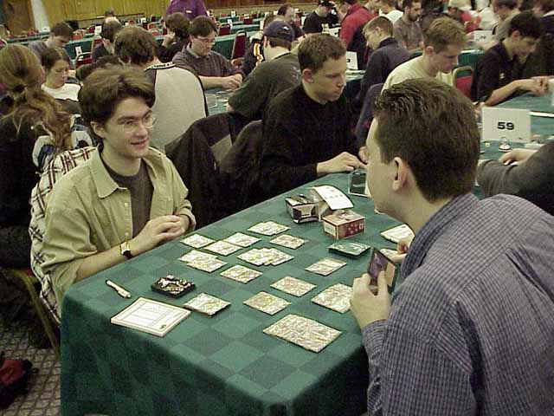
Dobson plays Scott Wills
Tony Dobson - The second Englishman (After Ormerod) to make a Top 8, it was Tony's performance at Chicago that made the world take notice. Tony possesses a singular mind that sees him take one activity, food (steak) or what have you and focus wholly on it. Also possessing of a number of important non-PT Top 8 finishes, it's Tony's love for games as a whole that makes him a gamer's gamer.
Scott Wills - This may be the man who will revolutionize Limited play. The oft-times dour but always introspective 'Swills' is probably best remembered for his leading of World Championships 2000 after Day 1 (when he played Replenish), but its what he's working on right now that makes him a potentially explosive in the PT universe. Scott has started testing Limited in a whole new light, literally building archetype decks based on realistic draft projections for the purposes of learning what makes or breaks a deck, metagame or match up. He's only applied his theories in a limited capacity for Barcelona, but it will be interesting to see how his work will affect the results for the English, who are often mocked for their drafting.
It's these five players who form the core of the English professional community. Others, like Pete Norris, Mark Wraith, Ivan 'Burgers' Ronaldson (Ben's older brother) and Ollie Schneider are becoming more familiar on the PT, suggesting that a further English invasion is still to come. If their improvement continues at the alarming rate it has, those of us playing from the other side of the Ocean may become obsolete.

(The following was written three days after what you've just read)
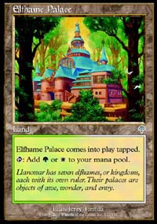
When you come from North America, nothing can really prepare you for palace life. Of course, not many North Americans know this because we don't have to age-old testaments to regality that dot the countries of Europe. I always knew Ben and Ivan Ronaldson lived in a palace. I knew I'd be visiting them at said palace. What I didn't appreciate was just how overwhelming that first contact would be.
Ben and Ivan are the sons of champions. Real tennis, for those 99% of you who haven't heard of it, is the Amoeba from which all other racket games evolved. Similar to lawn tennis, it's played on a hard court with no out-of-bounds, with the court outlined by multi-angled walls off which the ball is allowed to carom. It's a game loved by all expert lawn tennis types who try it, with the power and speed of the newer model being replace by the finesse and prestige of the old. There are thirty-five courts in the world.
Chris Ronaldson, Ben and Ivan's father, was the game's World Champion seven years in a row. Upon the completion of his career, he was considered by many to be the greatest Real Tennis player of all time. Their mother, Lesley, was for many years a women's doubles champion. Of course, there were expectations.
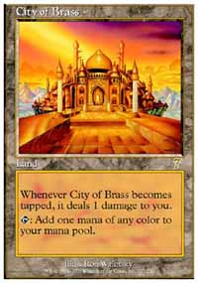
By their own words, Ben and Ivan are both amongst the top 35 some-odd players in the world. Ivan, born with the broad shouldered body type of an American athlete, has seen that physique hinder him as a player, in that the constant pounding his body takes from running on the game's hard surface has taken it toll on his back, but he's considered the hardest hitter in the game today. Ben, the more lithe of the two, is felt to hold the potential to reach the game's elite circle, but there's another game, another mistress, who holds his attention.
With the entire family's expertise in the game being evident, it was only natural that it be they who be hired to run Hampton Court Palace's Real Tennis program, and part of the deal was living space in what used to be servant quarters. Of course, in a place like the palace, even the servants lived regally, so their existence is a comfortable one lived in huge rooms that are constantly rediscovered.
The grounds here are immense, stretching more than a square mile. The gardens, constantly tended to by a staff of many, require ten million pounds ($16 million) to maintain annually. When I awake in my arena-like guest quarters, I can look out my window and watch as swans split the Thames River in two with their wake as they swim to their mates.
Nearing 500 years of age, Hampton Court Palace is considered by many to the finest structure in England, so my exposure to it was shocking. From the immensity of the thing to the guards to the rivers flowing through to the rows of neatly carved trees, each step brings me to new wonders that I never thought this gamer's eyes would see, at least not as more than anything but a tourist trap. This week, though, this is home. The whole thing is inspirational.

I guess what I'm saying is that it's all been worth it.
This is what makes my job so great: the fact that my connection with the Pro Tour has led to my meeting all kinds of people from all kinds of places and backgrounds. This month, I've had Dom Perrignon, and lived palace life (and will continue to do so for a few days more) all the while making a living doing something I love to do. I know that if I were to ever win the lottery, I would keep writing and playing the game just as I have. I know I've got it good.
It's all of this, the inspiration, the fun, the experience that makes it all worthwhile. Am I making a doctor's living? No, of course not, but when it comes to the intangibles, I'm getting so much more. At 28, I've seen the whole world. I've been to every inhabited continent but one (Africa, where I hope to go this year for the Invitational) and traveled more than 99.9% of those who have ever lived.
I guess what I'm saying is that it's all been worth it. Traveling to PTQs only to lose my last match, getting mana screwed out of more than one PT Top 8, going through trials and tribulations with similarly strong-headed judges and players, confusing my family and friends about what it is I do ("A gambler" is what my mother thought I was until I sat her down and explained it a third time), the Pro Tour has been an amazing whirlwind that doesn't seem to be slowing down any time soon. For you cynics out there, there isn't an end in sight: Magic will go on.
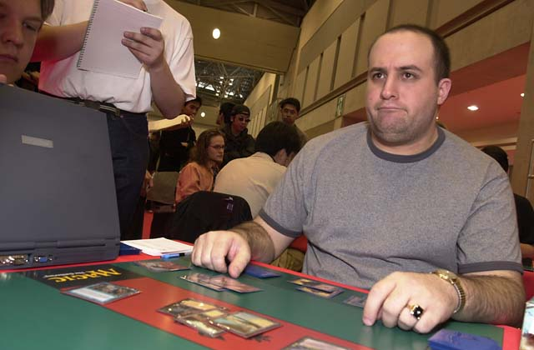
So for those of you out there who are fighting your parents and alienating your friends all for the cause of this silly little card game, know that when you finally get here, we'll be waiting. The Pro Tour, its stars and its money are going to be around for a while. It may not be Hampton Court Palace, but really, what is?
Use all this as your inspiration. Know that if you're one of the lucky ones, one of the hundred out of six million (and growing) who gets through those heart-wrenching PTQ Top 8s, finally makes the Pro Tour, makes it again after getting outplayed the first time, makes it again after getting mana screwed the second time and time and time again goes through the process to finally make the gravy train only to realize that you still aren't making money thanks to your travel costs until you make your Top 8, there can be a life of experience and wonderment waiting for you on the other side. That's the hope you have to have: that's your inspiration.
Keep working harder than anyone else. You have to believe with your whole heart you can get here. I'll see you on the other side, and we can walk the palace grounds together, talking Magic and history and life.
That's it for this week, though I'm sure I'll be inspired to write a little more. As always, feel free to e-mail me at JGaryWise@yahoo.com with questions or comments about the content of Wise Words. I hope you'll have a good week: I know I will.

